Pacific Storms Climatology Products (PSCP)

Website Developer Documentation



Author(s): Ian Schneider, Rob Allen
Create Date: 2010-01-13
Last Modified: 5/9/2012 8:07 PM
Copyright ©, 2011, RIVERSIDE Technology, Inc. All rights reserved
Table of Contents
Pacific Storms Climatology Products (PSCP) 1
Website Developer Documentation 1
Introduction 3
Genesis 3
Who Should Read This Document 3
Technologies 3
Caveats 4
Version Control 4
Project Physical Structure 4
The Java Restlet Project 5
PHP Project 6
Website Overview 6
stations.php 7
query/results.php 7
Javascript Overview 9
Database Design 10
Accounts 11
Products 11
Deployment 11
Building the Distribution 12
Install the Distribution on the Target Machine 12
Customizing an Installation for a Machine 12
Running the Installation 13
Updating an Installation 13
Other Configuration Options 14
The Staging Machine 14
Reverse Proxy 15
Known Issues 15
URL Reference 16

Introduction
This document provides information about the Pacific Storms Climatology Products (PSCP) website created for the National Oceanic and Atmospheric Administration (NOAA).

Genesis
The technologies that are used are essentially the same as the initial website developed by Uday Kari. However, the following changes have been implemented from the initial website:

- The database design was modified slightly from the original, with additions allowing for versioning of products as well as user password and roles. More constraints and indexes were added to facilitate data integrity and improved performance.
- An administrative interface was added to allow product and station upload via the web interface. Use passwords are stored encrypted in the database and the HTTP digest authentication method is used for secure password transfer.
- Stations and products are loaded separately and the database is no longer rebuilt from scratch on ingest. Instead a surrogate key is used to match existing definitions and these are updated.
- The NOAA styles were updated from the NOAA website and as much as possible, the format was adhered to.
- The Java Restlet library replaced the use of Servlets and the Freemarker templating library replaced JSPs. In this case though, Restlet actually runs on top of Servlets in Tomcat.
- A set of usability and convenience enhancements was implemented (documented elsewhere) during the late summer/early fall of 2011.

The initial web site that was the source of work was provided by Uday and Uday configured the initial site on the Riverside server. From that point, Riverside staff (mainly Ian Schneider) migrated the site to that described in this document. Rob Allen took over from Ian in August of 2011 and implemented the changes described in PSCP Punch List.doc.

Who Should Read This Document
The main purpose of this document is to help developers understand technologies, design and development issues. However, individuals involved in deploying, troubleshooting, testing and documenting the application will no doubt find much of the information contained herein useful.

Technologies
In addition to the Java (JDK 1.6), PHP (5) and standard web technologies, a number of open source technologies have been employed in the development of the application. A partial list is included here:
Technology | Purpose
PostgreSQL | Database persistence
JQuery | Simplify scripting
JSON | Web services as Javascript objects
FREEMarker | Use .html files as output templates
Rest | Better web services
Google Maps | Integrated mapping for the user interface

Each of these technologies is described in more detail, including how they are used in the PSCP application in later sections of this document.

In addition, several tools were used during development, particularly the Netbeans IDE; although the project should be portable to any other Java IDE. The build and deploy processes use Ant.

Consequently, it is recommended that developers use Netbeans to fix bugs and enhance the application. The Firefox plugin Firebug is useful for understanding HTML, CSS, AJAX, and HTTP headers.

Excellent documentation exists for many of the underlying technologies used in the PSCP project:
- Leonard Richardson and Sam Ruby, Restful Web Services, Web services for the real world, O-Reilly Media, May 2007.
- Author unknown, http://freemarker.org/
- Author unknown, http://code.google.com/apis/maps/documentation/javascript/v2/reference.htm

Caveats
The project documentation is thin. Consequently, there is very little information about the business requirements that drove the technology and implementation decisions.

The code level documentation is next to non-existent. Where possible, the latter author has attempted to fill in some of the blanks of the more confusing aspects of the architecture and design, but much of the source code remains undocumented. This is particularly pernicious when dealing with the JQuery scripts which appear to have been intentionally obfuscated to make it difficult for third parties to reverse engineer the application (personal communication with Steve Malers). This seems to contradict the strategy employed by the use of Restful Services, which are intended to expose content to third party developers. The obfuscation is even more frustrating when the developer realizes that there is nothing special, unique or proprietary about what the JQuery code does.

Version Control
The PSCP Website uses Subversion (SVN) for version control. Developers must have access to the jackson.riverside.com SVN server, which requires using the Riverside VPN if outside of the Fort Collins office.
There is a “metadata” project at svn://jackson.riverside.com/svn/rtisw/trunk/ProductMetaData/webapp.pscp.
This project (a directory) uses the SVN “externals” property to include two repository trees:
svn://jackson.riverside.com/svn/rtisw/trunk/webapp.pscp.restlet
svn://jackson.riverside.com/svn/rtisw/trunk/webapp.pscp.php
Upon checkout, the following directory structure should be present:
webapp.pscp/ (main project folder)
webapp.pscp.restlet/
webapp.pscp.php/

The following section describes the contents of the project files in more detail.

Project Physical Structure
The PSCP website is organized into two separate projects as follows:
- A Java Restlet application that runs on the server and provides dynamic information.
- A PHP project consisting of static pages, css, and javascript that comprise the bulk of the website content.
The Java Restlet project can be considered the main project and its Ant build process packages the PHP project.
Each project is described in greater detail in what follows.

The Java Restlet Project
The Java Restlet project provides a REST API to the application. The project is structured as a Netbeans Web project and uses the Restlet Servlet adapter. Additional libraries include JSON support, Freemarker template support, PostgreSQL JDBC driver, and Apache commons file upload.
In addition to all of the relevant Servlet configuration and Restlet source code, this project contains the master build Ant script, the deployment Ant script, and Freemarker template files.
The Java packaging is broken up into several packages. When possible, application-specific code is placed into a package prefixed by pspc. Those not prefixed by pscp are potentially reusable outside the context of this application […].
The contents of the webapp.pscp.restlet project are:
File/Folder | Description
build.xml | Ant build script for development
pscp-install.xml | Ant installation script for deployment
conf | Apache configuration template used during deployment
doc | Documentation
lib | Java libraries
nbproject | Netbeans project folder
scripts | Various non-production utilities
sql | SQL schema definitions and fixture data
src | Java source code
test | Test code
web | WAR packaging contents and freemarker templates.

The core restlet packages under src/java are:

Package | Description
pscp.restlet | Main application, URL lookup, JDBC DataSource
pscp.restlet.resource | All application resources and base classes
pscp.restlet.template | Utilities related to Freemarker/DAO layer integration
pscp.restlet.util | Various utilities, mostly reusable, some Restlet dependence

A simple auto generated table/column binding DAO layer (see src/java/dao) is used to abstract database access. The generation script is located in the scripts directory and required Jython-2.5 to run. DAO classes reflect various tables and views in the database. This layer offers fairly tightly coupled name/type information and adds some resource management and transaction functionality on top of simple CRUD operations.
The restlet project provides all of the low-level data access and administrative functionality for the application. As much as possible, micro-formats and xhtml fragments are used for data presentation. The generation of this data is done via Freemarker templates.
A minimal fuzz test is provided for DAO and Restlet regressions. These are done using JUnit and located in the test/ directory.

PHP Project
The PHP project provides a more complete view on the Restlet API, providing styles and static content to give the data some context. This approach was chosen to make static content development relatively easy. The PHP project uses Apache redirects and PHP templating to support various URL prefixes. For example, everything in the /content PHP project directory corresponds to a URL that is accessible from the root of the application, e.g. content/about.php is reached via http://<host>/<root>/about.php. For example, during development at Riverside, the URL is http://williamsfork.riverside.com/pscp/about.php .
A similar configuration exists for the /admin and /admin/content directory. This is done to enforce authentication rules for all URLs in below. For example, during development at Riverside, the URL was
http://williamsfork.riverside.com/pscp/admin/
The following describes webapp.pscp.php directory contents:
Directory | Contents
about | Description of product types, extracted from the “Project Framework and Derived Data Products Guide” and manually converted.
admin | Admin pages, templates, includes, and access control code. This is protected and requires authorization.
content | Root content – the main, publicly accessible website.
css | Global CSS used for public and admin pages. The basic structure and names mirror that of the original AGU site.
help | Global Help, currently only describes the upload process
images | Images and image download script, which converts the UUID of ingested images into a human-readable name and serves them up as an attachment (prompts web browser to save file)
inc | Root includes and global definitions – the basic structure of the includes mirrors that of the original AGU site.
js | Global Javascript – as much as possible, scripts have been named for the page in which they are used.

As much as possible, shared code and information has been defined in files in the “inc” and “js” directories, which are included as appropriate.
As much as possible, the PHP project does not directly access the database. Instead, the PHP pages render AJAX enabled static markup that relies on the Restlet services for obtaining micro formatted data. The exceptions to the direct database access rules are for login, simple station counts – pending, and product image access. The latter functionality supports accessing uploaded products (that receive a UUID [universally unique identifier] for a file name) as an attachment download (i.e. instead of downloading “a5488920-d52a-4fbc-8399-0f8a7cfdddc8.png”, the script resolves that this means
HR 5 day HI_WAIMEA_947_.png” [see KnownIssues#Product1]).

Website Overview
The end user interactions are done primarily through the PHP pages in the site, which load mostly static content via the includes templating system borrowed from the original AGU web site. The javascript libraries loaded into the browser enable the dynamic access of data from the Restlet backend API based upon the state of the browser. For example, when the user selects a region in the product viewer page, the javascript makes a request to find all the stations in that region. The results are parsed and added to the map and side panel. The admin interface also makes use of this technique.

For more details on the URLs of the backend, see the URL Reference section.

The main functionality of the site includes:
- Static content – overviews, regional overviews, about this product, glossary, etc.
- Station and product query pages that allow users to view the data

For the static content pages, the PHP templating system pulls together the various parts of a page, header, footer, links, etc. and combines them with the “main” content of a given page.

To help explain the interaction between the PHP and Restlet components of the application, a quick overview of the stations.php and query/results.php pages follows:

stations.php
The goal of this page is to present the list of all the stations, provide a simple filtering capability and allow the user to go any of the station pages where the station information and associated products are presented in detail.

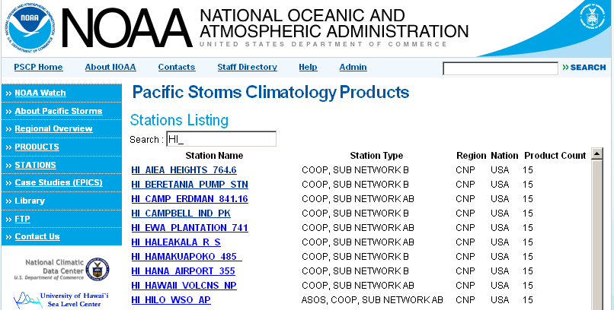
Partial view of stations.php (stations.png) showing a filter being applied

After the PHP page loads, a JQuery script performs an in-line AJAX request to the stations overview Restlet resource (pscp-api/stations/overview). The results of this request (an HTML table) are injected into the DOM. A quick search function is bound to the HTML input element at the top. This enables the user to perform a client side filter of all station attributes using a case-insensitive regular expression test. The script also adds a click handler to the station table links to ensure they open in a new window.

query/results.php
The goal of these two pages is allow the user to specify a product query using one of the regions (NNP,CNP,etc.) along with one of the producttypes (1.1, 1.2, etc.) and a process/indicator pair (HR 1day, etc.).

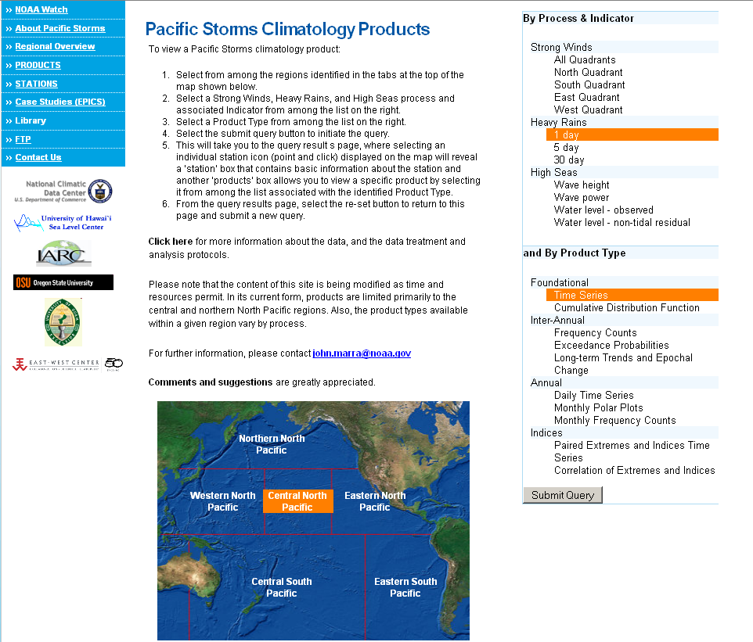
Partial view of query.php (query.png) showing a region, producttype and process selection.

The query page does not actually make any use of the Restlet services, as the regions, producttypes, and process/indicator pairs are stable. As a result, these are hard-coded to make things easier. The query page uses a JQuery script to enable the selection of normal DOM elements (like the region links on the map and the producttypes and process/indicator pair lists on the right side) and when all are selected, enables the Submit Query button. When pressed, the JQuery script computes a hash URL fragment to request the results.php page with. In the case of the above example, this hash looks like:
#region=CNP&process=HR&typeid=1&indicator=1+day

The results.php page displays a Google map with the relevant stations both listed on the side and on the map, zoomed to the extent of the data. The user can select a station to view the station information and associated products in a map popup. The region portion of the query can be modified by selecting one of the tabs across the top.

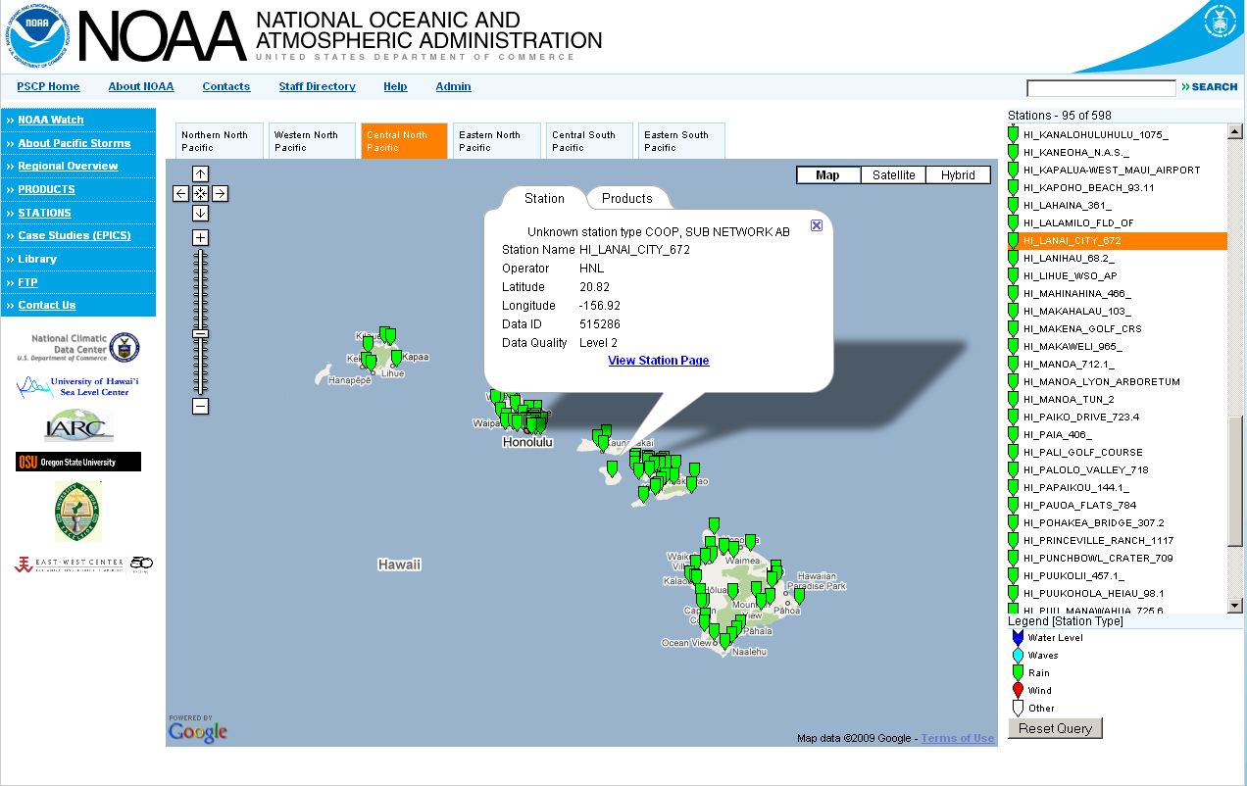
Partial view of results.php (results.png) showing the popup for a selected station.

The results.php page itself does not perform a query to obtain data, but loads a JQuery and Google maps Javascript library to enable the dynamic functionality. The script parses the hash provided to the page to determine the query parameters. The parameters are then used to issue an AJAX query get to the station locations service. In the above example, the URL used was:
http://williamsfork.riverside.com/pscp-api/stations/locations.js?region=CNP&process=HR&typeid=1&indicator=1+day
The results of this query are returned in JSON form. The JQuery script then iterates over the results, adding a marker to the map for each station as well as an entry in the stations list. Event handlers are added to each marker to allow popup display. The stations list also detects mouse clicks and forwards the event to the associated marker. The marker contents are also loaded via AJAX as the return fields in the initial station JSON specify what URL to use to obtain information and products for a given station.

This “lazy” loading of information allows this page to render very fast. For example, in the example query shown above, the station JSON for 96 stations is (compressed) 2KB, taking 520 ms. The station info and products list for a single station is a total of .8KB taking 9ms and 157 ms respectively. If all the stations and products information was loaded at once, the total data size would be 2KB + .8KB * 96, or ~79KB. Assuming a linear relationship for query time (given the complexity of the station products query – a view query with 3 predicates including a complex subquery), the time for that request would be a theoretical 16 seconds! Instead the entire page load, including Google map tiles, the stations list, and the data for an individual station takes 2 seconds.

Javascript Overview
As much as possible, DOM manipulations and effects are all done using the JQuery library. To enable browser history and deep-linking, a JQuery history plugin is used. This is perhaps the most complex aspect of the application. The general strategy to enable history and deep-links is to modify the browsers URL hash – this is the portion of the URL that resides behind the # (or hash). This part affects only the client and changing it represents a state change on the client, not the server. In terms of code logic, there are two activities with hash state – storing it or loading it. The best approach to maintain sanity is to have all UI elements modify hash state directly – normal event handlers are not used. A single event handler is registered to changes in the hash state. This handler then parses the new state and takes the appropriate action. On page load, this handler is also invoked, allowing for a deep-link to be evaluated.

For example, on both map viewing pages, when a region is selected (regardless of UI type), the region state is pushed to the hash. The handler for hash changes is invoked and the state is parsed out. The next step is to make the region selector UI reflect the new state, then to update the query for stations.

Other Javascript functions exist to make the admin interface easier to use (like form validation, text field completion, etc.) and are not critical to overall public functionality.

Database Design
The main goal of the database is to store stations and their relevant attributes and meta-data, datasets and their source identifiers (an external ID), product definitions (what station, what type and name), and actual graphics products and their revisions.

The database schema is derived from the document entitled “PRICIP DDP_product schema_2.2.doc”.

The database was developed using PostgreSQL8.3 and as much as possible, uses standard SQL. There are no stored procedures.
The following tables are static fixture data (there is no web interface to allow editing of these):
Table | Description
nations | Nation names and 3 character ISO codes, see http://en.wikipedia.org/wiki/ISO_3166-1_alpha-3
productname | Product names (generated from python script project-type-gen.py) – these are the specific product names
producttype | Product types – each type has one or more product names in it. See the document entitled “Project Framework and Derived Data Products Guide 2009”
regions | Regions of interest (NNP, ENP, etc.). “Project Framework and Derived Data Products Guide 2009”

The following tables, while containing more dynamic data, will not change much (a user interface is provided for editing contacts):
Table | Description
contacts | Product providers and administrators. Contains encrypted passwords and contact info, that is used to identify products with suppliers, and is also used by the upload process.
operators | Lookup table of station operator names (agencies). Operator names and generated ID are added during ingestion.

The following tables contain the stations, datasets, product definitions and related revisions (allows versioning of products). These are edited via bulk station/product list ingest or via a user interface:
Table | Description
stations | Station information, including the id of the dataset at a station. [See KnownIssue#DB1]
datasets | Dataset description including metadata link and quality level.
products | Actual product definition – station (and therefore dataset [See KnownIssue#DB2]), product name (and therefore producttype), contact, and active revision.
productrev | Product revisions – track actual product file revisions. Includes name of product file, submitter, comment, date changed, MD5 sum.

The following views support more advanced queries and summary information:

View | Description
productlinks | Join products to productname and productrev to support finding the URL to the current product.
productnamecnt | Extend productname with counts of actual products for each name.
productrevlocation | Join product file name to product type and name to support reverse lookup [See KnownIssue#Product1]
producttypecnt | Extend producttype with counts of actual products for each type.
stationdata | Join station and dataset together to facilitate station ingestion.
stationsp | Join station and products with productname and producttype (Stations Products).

As noted above, most of the DAO functionality includes straight table/view “select alls” with a few multi predicate queries. The one exception to this is the query used by the results.php page to select stations in a specified region and process using one or more product types and process indicators (dao.pscp.Stations.readStationLocations).

Accounts
The contacts table stores account information for users as well as product providers. A user will be able to login only if he/she has a password entry. The password entry is encrypted. An account with the login Test and password TeStEr765 is provided.

When a user logs in, the UUID of that user is stored in a cookie that allows the PHP parts of the website to identify the user by name, e.g. “You are logged in as Test”. The absence of this cookie also allows the PHP admin pages to redirect the client to a Restlet login service that performs the digest authentication and then sets the cookie.

Products
In the Pacific Storms Climatology Products web application, a product is represented by an image file. Product image files should be placed into the /products folder under the webapp.pscp/webapp.pscp.php folder. This is normally done automatically by the administration tool when products are uploaded to the application.

While the application displays products, the products files are not contained in the source repository and are not deployed when the system is installed. It is up to the operator of the website to install and maintain these resources.

Deployment
For the information presented in this section, a working knowledge of Ant is assumed.

The usual procedure is to 1) use Ant to build the distribution, 2) move the built distribution to the target machine and 3) use Ant to install the distribution on the target machine. Steps one and three are described in more detail in what follows.

Building the Distribution
The main Ant build script, build.xml, contains targets to create the various artifacts of the distribution as well as to deploy the artifacts to the Riverside FTP. You may use NetBeans (or other IDE) to build the application, or you may build the application on a command line using Ant.

Normally, the build script places the built distribution in the folder entitled:

C:\[svn_root]\webapp.pscp\webapp.pscp.restlet\dist

where svn_root is the folder where you have checked out the project. Some targets place the distribution elsewhere (consult the build.xml file to find out which targets do this). After building the distribution, the dist folder normally contains the following files:

File Name | Purpose
pscp.conf | Apache configuration options.
pscp.properties | Local property definitions for the installation on the target machine. This file should be modified for each target machine.
pscp.web.zip | Zip archive containing web content, including PHP, CSS and script files.
pscp-api.war | War file containing the java restlet applilcation.
pscp-install.xml | The ant script used to install the distribution on the target machine.
update.sql | Optional file containing arbitrary SQL to update the database on the target machine.

When updating an existing installation of the application (as opposed to creating it initially), use the update target to build the distribution. The update target does not include the scripts and data used to set up and initially populate the database. Instead, it provides a script (update.sql) that can be used to make adjustments to the existing database via a set of arbitrary SQL commands.

Install the Distribution on the Target Machine
Once the distribution has been created (see the section entitled Build the Distribution), it contains an Ant build script named pscp-install.xml that, when invoked, deploys and configures the application on a target machine.

It is assumed that Ant, Java, Apache Tomcat, PostgreSQL, PHP5, and Apache HTTPD are all installed and configured. Warning: the deployment script does not install/modify mod_jk configuration or the associated commonly-named workers.properties file.

Begin by moving the distribution files you created previously to the target machine.

When updating an existing installation of the application (as opposed to creating it initially), use the update target when installing the distribution. The update target does not modify the database. Instead, it runs a script (update.sql) that can be used to make adjustments to the existing database via a set of arbitrary SQL commands.

WARNING: The deploy script targets not entitled update will overwrite any existing data or content files. If additional work is done after the handoff, the site contents should be synced to a local repository checkout before proceeding with more development.

Customizing an Installation for a Machine
The installation script relies on a local properties file to define custom settings and paths local to the target machine. This file should be located in the same directory as the deployment script and named pscp.properties. The properties defined in this file override similarly-named properties in the deployment script. Consult the pscp-install.xml deployment script to learn more about the list of properties that may be customized with the pscp.properties file.

On the williamsfork development machine (which was setup and configured by Uday in a very similar fashion to the deployment setup), the pscp.properties file contained only one property, the install location of postgresql and its associated binaries:

pg.home=c:/postgresql-8.3.5-2

For the linux virtual machine, also used during initial development, the file was a bit more complicated:

psql=/usr/bin/psql
pg_restore=/usr/bin/pg_restore
apache.root=/var/www
php.dest=pscp2
skip.apache.conf=true
skip.ftp=true
host.fqn=localhost
tomcat.home=/home/iws/software/apache-tomcat-5.5.25
The most important properties to configure are the database information (install location, login, etc.), the host.fqn (fully qualified name), pscp.upload.root (location to store uploaded files and ingest logs), Google maps API key, and tomcat administration login/password. Other potentially important properties include the location of the apache root and tomcat install location. It is strongly advised that you verify these properties for correctness before running the pscp-install.xml script.

Once the pscp.properties file has been correctly set up, the deployment script can be run.

Running the Installation
The default Ant target in pscp-install.xml installs the entire application, including the database, the PHP project, and the Restlet project. These targets can be run individually as specified by web, db, and servlet, respectively.

By default, the deployment script requires FTP access to Riverside’s FTP site (check firewall etc. if this does not work). If no FTP access is available from the destination/install machine, use another machine to get the files and copy them to the logged in users temporary directory (C:/Documents and Settings/<User>/Local Settings/Temp). In the pscp.properties file, define the property skip.ftp=true.

The deployment script will only download new files from the FTP site, but redeployment can be done at any time by running the appropriate target. The downloaded files are stored in the temp directory for the system being installed on, though this can be changed by providing a property (ftp.dest.dir).

Updating an Installation
Targets have been added to the pscp-install.xml for lighter-weight installations that don’t replace the database (e.g., update). When using the update target, be sure to specify the skip.ftp switch. For example:

ant –Dskip.ftp=true pscp-install.xml update

When updating the installation, be sure to use the pscp.properties file that you may have previously set up for the target computer.

Other Configuration Options
Once the system has been installed, you can modify the web.xml file to fine tune the installation.

For example, the named parameter pscp.product.root specifies the location of product image files when the Upload Products feature is used in the PSCP Administrator. This folder is normally named products and is located just off the web server’s configured document root. As in the example below, it is best to use an absolute path.

<!-- PRODUCT UPLOAD FINAL DESTINATION -->
<context-param>
<description>For development, this can be anywhere. If the location does not exist, then the
servlet will use TEMP/pscp-uploads (relative to Tomcat) and it will log a message.</description>
<param-name>pscp.product.root</param-name>
<param-value>C:/rtisw/webapp.pscp/webapp.pscp.php/products</param-value>
</context-param>

The Staging Machine
A virtual machine has been set up for the purpose of testing the deployment scripts and providing a place for NOAA staff to view the application. This is particularly helpful when changes have been made but not yet deployed on the NOAA production server. The URL of the machine is: //pscp-dev.

The proper Google map key for the staging machine is:

ABQIAAAA9lBkoEkdPIZ2IusUUo5_IxQ0_1wtHV5MBckgrAXLGy9Gdh7vBxQT_dZauJX_8S_Ic2-vsm25wGcJSg
The Google map key may be specified during installation by placing it in the pscp.properties file prior to running the installation script, as follows:

<property name="google.key" value="ABQIAAAAg66ljWi8jUinaW9col7DqxSmYwebCFVuhfOcQad8g2y0xtCVXxQgbQ6_ERk8yLjOGwpXKZ7yymasIw" description="google key value"/>

If the application has already been installed, you can replace the Google map key reference in the [apache-root]\htdocs\inc\google-key.php file. Note that the google-key.php file is replaced by subsequent installs, so it’s a good idea to keep the key up to date in the pscp.properties file.

Note: Google map keys are bound to a specific URL. Each machine must have its own unique Google map key. Keys may be generated at Google’s map website.

The staging machine is behind the Riverside firewall and is not normally accessible to those outside the firewall. However, an exception has been made for the NOAA IDEA center. HTTP requests originating from the IDEA center are passed through the firewall to the \\pscp-dev machine. The URL to access the staging machine in this way is:

http://tetsel.riverside.com

This URL may be used both inside and outside the firewall.

Reverse Proxy
Note: the reverse proxy mechanism is not currently employed at Riverside. The following information is included in the event that the use of the reverse proxy becomes necessary at some point in the future.

As the staging machine is behind the Riverside firewall, in order for NOAA staff to view the application, NOAA staff must access the staging machine via the reverse proxy server on buckeye.

The staging machine at //PSCP-DEV presents an interesting twist when it is accessed via the reverse proxy server on buckeye (http://buckeye/cgi-bin/proxylist). The reverse proxy server interprets requests for the root directory as its own root directory, rather than the root directory of the website it is serving. At first blush, this appears to have an effect only upon style sheets that are referenced with an absolute path (e.g., /css/mystyle.css). However, the problem is much subtler and difficult to deal with.

Known Issues
The following issues/details/complexities exist. The site is functional; however, the following issues should be evaluated to improve the design and functionality in future updates.
ID | Name | Description
DB1 | No support for multiple datasets per station | Currently only one dataset per station is supported. This can be extended either by adding a new column to the stations table or through a relation table. Because only one additional dataset (derived) is expected, the former approach is recommended.
DB2 | No support for differentiation of dataset types. | The datasets table contains a column to differentiate derived datasets from archived, but it is not used. See DB1.
Product1 | Opaque product name versus complicated product name. | The product file names are currently being generated using a UUID. This avoids problems with unique names (especially when adding the revision field) but complicates 2 other aspects:  1) Linking to images and thumbs is easy, but supporting user download of a human-named file is made complicated (see webapp.pscp.php/images/product.php)  2) Product file migration/management is difficult. No tools currently exist to assist with this, though the information is all present.
Product2 | Product files are PNG, thumbnails are GIF. | During development, it was found that the GIF thumbs scaled better (appearance and file size). This complicates access to products and thumbs.
Deploy1 | Deployment does not configure mod_jk or workers.properties | Apache fronting Tomcat via mod_jk is still the recommended solution, but mod_jk configuration is global and may break existing apps/config.
Goog1 | Google Maps version 2 is deprecated. | According to the Google Maps website, version 2 of the API was deprecated as of 5/19/2010. This means that the API will not function as of 5/19/2013. The site must be migrated to version 3 prior to the drop dead date.

URL Reference
Once properly installed, the application (using the default configuration) relies on two URL roots:

http://host.fqn/pscp/
http://host.fqn/pscp-api/

The first is served via the PHP project and provides the content suitable for normal users, the second is the Restlet project, and will present the user with a list of services provided behind the scenes, which can be drilled down to access more resources. The API is useful for development and testing, and to provide individual resources to the main site pages. Those URLs beginning with admin require authorization.

